Exp.No:4
Date:
MATERIAL HANDLING SYSTEM

AIM:

To develop a ladder logic program for the material handling system.

APPARATUS REQUIRED:
1. Material Handling system.
2. PLC
3. Versapro Software
4. PC
5. RS-232 Cable.
6. Patch Chords

PROCEDURE:

1. Load the Versapro Software to the PC.
2. Open the Versapro Software.
3. Switch ON the PLC Trainer and Material handling system.
4. Connect PLC and Material handling System kit.
5. Open the New folder and draw the ladder logic program.
6. Connect the PLC to PC.
7. Select the correct hardware Configuration [Sl. No].
8. Store the Program to PLC.
9. Run the Program.
10. Verify the performance of the Material handling System.

Problem statement:

In the material handling system first the arm is go to the initial position that means it is placed in the(i1) limit switch Point . Now the program in run the conveyer settings is role whenever the sensor (i3) is high at the time the conveyer setting action in stop now the arm is rotate the initial point to (i2) position. Whenever the input (i2) is high at the time the coil output is high now the coil is magnetized and to catch the material and rotate the reverse direction. Whenever as the arm is touch the I/P (i1) at the time the I/P 1 is high the coil O/P in low. So, the coil is demagnetized and the material is drop in the storage box.

The material handling system consists of the following interfaced to a micro PLC.
(i) Stepper motor 1- To rotate a container belt
(ii) Stepper motor 2- To move a arm
(iii) Electromagnet - To pick a material (It is mount in arm end)
(iv) Limit switches - To Control the arm position

WIRING DIAGRAM:

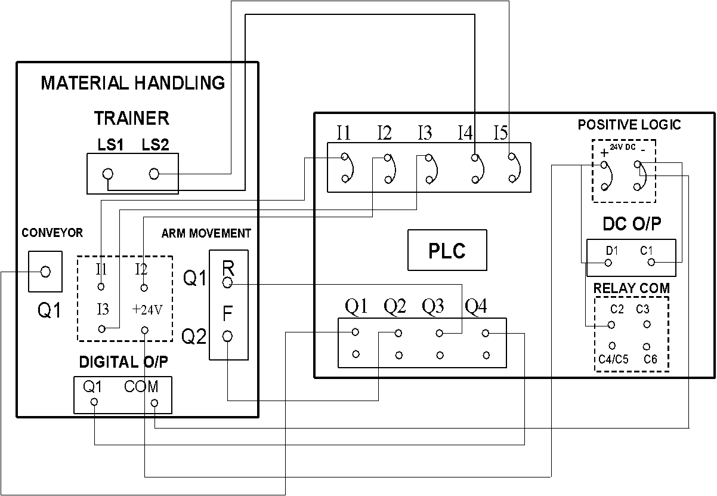

Inputs used:

(Describe here)

Outputs used:

(Describe here)

LADDER DIAGRAM:

I/O Mapping:

RESULT:
Thus the ladder logic program for the material handling system is developed and tested using hardware kit.

